**Data Collecting Instruction**

1. **Selecting the collecting grids according to the following manners**

1>select about every 2 meters

2>enough grid to cover every localization region as possible

3>the selecting distance can be properly extended for empty region

4>the region near to the walls and obstacles should select more grids

**The actual grids are showed as follows:**

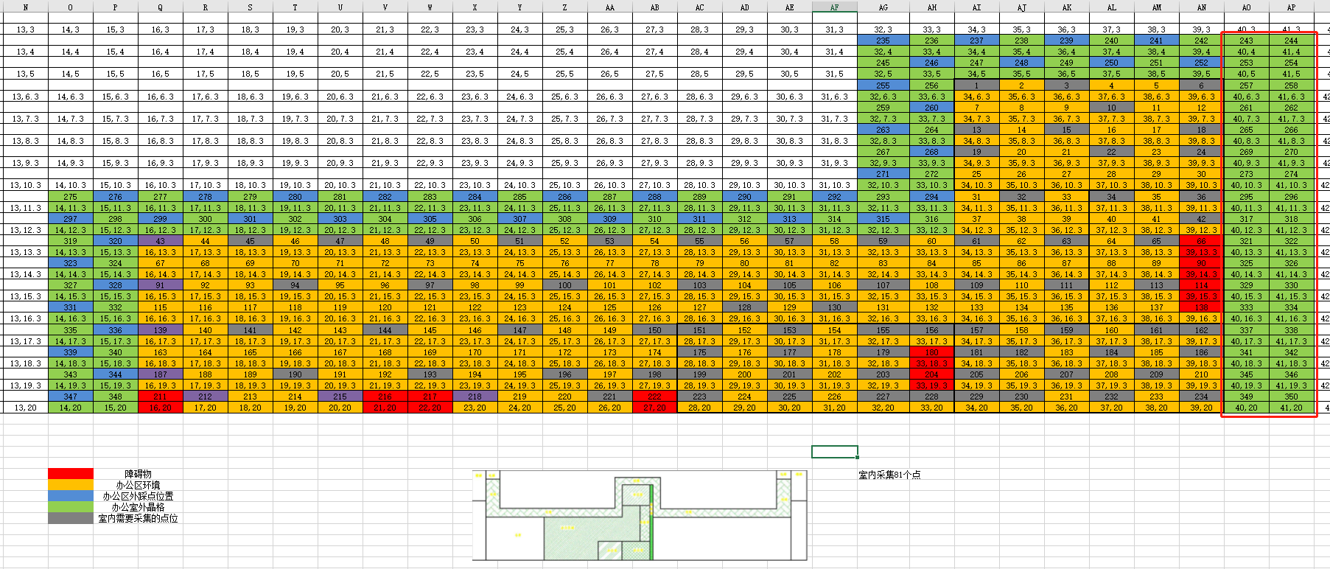

**Note: The red region denotes other companies, and it is not convenient to collect the sniffed data in these outdoor regions.**

1. **The mobile phone used**

Two Huawei phones were used (MAC address: B8:BC:1B:DB:EA:DD, 24:09:95:B2:90:9C）.All grids were collected by these two phones. It is not convenient to use the iPhone due to the owner need to used, so we only used two Android phones in this time. Therefore, Android phone will be used to validate the collecting data.

1. **The collecting manner**

According to the last communication, 2mins collecting time for every grid, each direction30s.

1. **The number of grids**

81 indoor grids and 41 outdoor grids.

1. **The MAC address and number of all 6 APs**

70:47:60:02:A3:0B-->1

70:47:60:02:A3:0C-->2

70:47:60:02:A3:0D-->3

70:47:60:02:A3:0E-->4

70:47:60:02:A3:0F-->5

70:47:60:02:A3:0A-->6